CS410 Project 1 – DFSM Simulation

The program should do the following:

read the DFSM from the user specified file

repeat

ask the user to input a string which can be empty

output “true” if the string is accepted by the machine, “false” otherwise.

Until the user wants to stop

Format of the DFSM file:

First row is alphabet separated by comma

Second row is the number of states of the DFSM, implicitly the states are 0,1, 2.. where 0 is the initial state

Third row is the accepting states: one or more separated by comma.

The remaining rows are the function, one row for each state

Example1

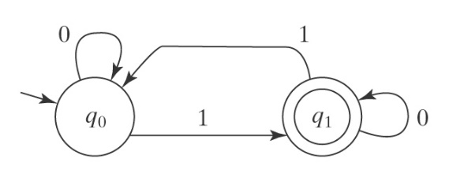

0, 1

2

1

(0, 0, 0), (0, 1, 1)

(1, 0, 1), (1, 1, 0)

Example2

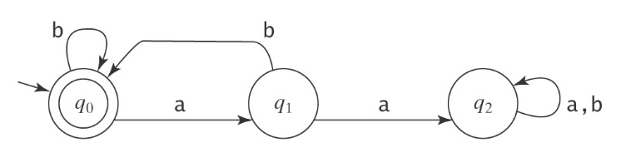

a, b

3

0, 1

(0, a, 1), (0, b, 0)

(1, a, 2), (1, b, 0)

(2, a, 2), (2, b, 2)

To be submitted:

Source code file in Java/C++

Input files you used for testing